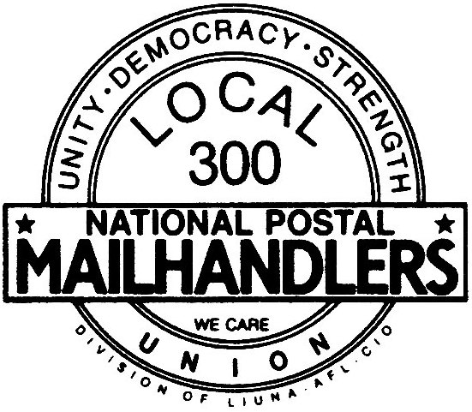
NATIONAL POSTAL MAIL HANDLERS UNION
LOCAL 300 AFL-CIO
www.local300npmhu.org
20 W 33rd ST Suite 8A New York, NY 10001-3305
Phone (212) 431-0040 Fax (212) 941-6499

Date

Step 2 Designee, title
Address

GRIEVANT:
ISSUE:
DATE:
Union Grievance Number:
USPS Case Number:

Dear Step 2 Designee:

This Union is in receipt of your Step 2 denial to the above-mentioned grievance. The decision was dated ***** **, 20**, and received on ***** **, 20**. Please note that, this labor organization finds your facts and contentions as set forth in your decision to be incomplete and inaccurate. As in accordance with Article 15.2 of the National Agreement, this Union shall set forth corrections and additions as deemed necessary by this labor organization. This statement shall be included as part of the case file of this grievance.

***type your additions and corrections here***

This Union has found numerous inaccuracies and contractual violations. Therefore, this labor organization rejects your Step 2 denial and forwards this grievance to the next step of the Grievance - Arbitration Procedure, applying full corrective measures.

Sincerely,

Your Name
Title

